**SAP Universe Designer Tutorial**

<https://www.tutorialspoint.com/sap_universe_designer/index.htm>

Once Semantic layer is built, you can publish it to ***BO server repository***.

Only Universe Designer users can view and edit this ***schema***.

Universe created using Universe Designer Tool has ***.unv*** extension. Universe contains classes /группы объектов/ and objects.

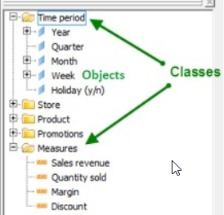

There are *three types of objects* used in a Universe

## *dimension*;

## *detail* - provides more information about dimensions like Phone number, address, etc.;

## *measures*.

When you install BI client tools, Universe Designer is part of client tools and can be opened under SAP BusinessObjects BI Platform Client Tools → ***Universe Design Tool***.

Universe are stored in ***CMS repository*** and user connects to universe using a web browser. When user connects to Universe, he can access all the data in a database.

### Secured

Secured connections are used to control data access and they are created using Universe design tool. You should use secured connection if you want to distribute Universe using CMS. You can also set a password on any Universe built on a personal or shared connection.

To set the password, navigate to **Tools → Options → Save tab**.

Universe are deployed when they are exported to CMS repository. When a Universe is exported to CMS repository, a unique system identifier is assigned by the CMS.

To export a Universe, go to File → Export. You need to select the target Universe domain and a group. If someone else is using Universe, it will be showed as greyed locked. You can double click to lock/unlock a Universe.

To manage access restrictions, navigation to Tools → Manage Security → Manage Access Restrictions. The dialog box appears.